🎓✨ AI Assisted Coding – Lab 18 ✨🎓

🌈 API Integration: External Services with Error Handling

🎨 📘 Student Details
🏷 Field | 📌 Info
📅 Assignment | 18.2
📚 Course | Ai_Assit_coding
👨‍🎓 Name | Seetharam
🆔 Roll No | 2303A52440
👥 Batch | 34
🎓 Program | B.Tech – CSE (AI & ML)
📖 Year/Sem | 3rd Year – 2nd Sem

🎯✨ Lab Objectives
- 🔗 Connect Python with APIs
- ⚡ Handle request/response
- 🧠 Implement error handling
- 🚀 Extract useful data

🧩🔥 TASK 1 – Air Quality API

💻🐍 Python Code
import requests
city = "Delhi"
try:
url = f"https://api.waqi.info/feed/{city}/?token=demo"
response = requests.get(url, timeout=5)
data = response.json()
if data['status'] == 'ok':
print("AQI:", data['data']['aqi'])
print("Dominant Pollutant:", data['data']['dominentpol'])
else:
print("Invalid city or API issue")
except requests.exceptions.Timeout:
print("Request Timeout")
except Exception as e:
print("Error:", e)

📸 Screenshots
👉 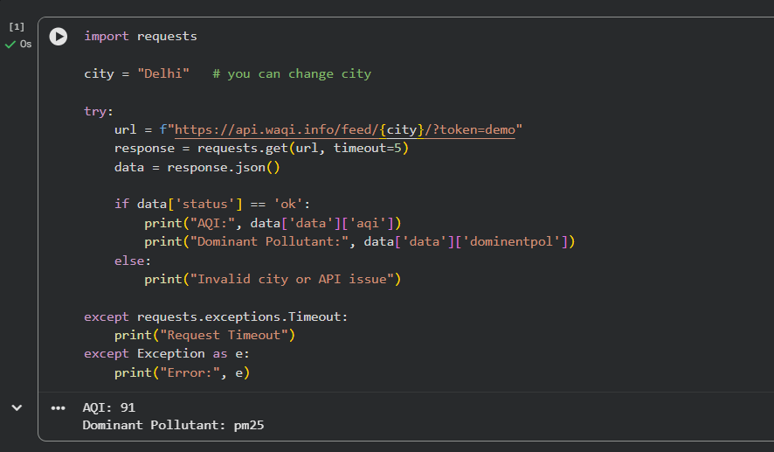

🧩🔥 TASK 2 – Language Translation

💻🐍 Python Code
import requests
text = "Welcome to AI Assisted Coding"
try:
url = "https://api.mymemory.translated.net/get"
params = {"q": text, "langpair": "en|fr"}
response = requests.get(url, params=params)
data = response.json()
print("Original:", text)
print("Translated:", data['responseData']['translatedText'])
except Exception as e:
print("Error:", e)

📸 Screenshots
👉 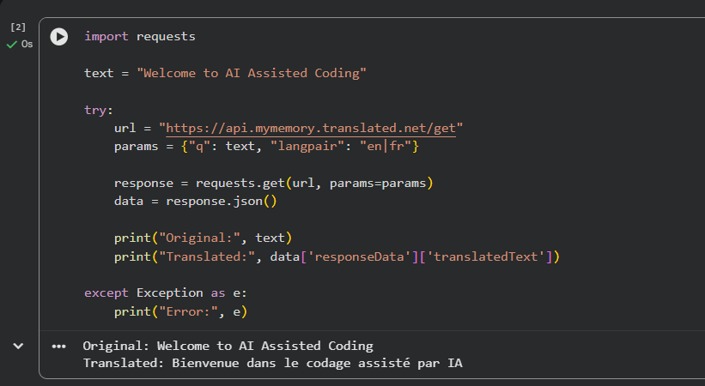

🧩🔥 TASK 3 – Book API

💻🐍 Python Code
import requests
query = "Artificial Intelligence"
try:
url = f"https://www.googleapis.com/books/v1/volumes?q={query}"
response = requests.get(url)
data = response.json()
book = data['items'][0]['volumeInfo']
print("Title:", book.get('title'))
print("Author:", book.get('authors'))
print("Publisher:", book.get('publisher'))
except Exception as e:
print("Error:", e)

📸 Screenshots
👉 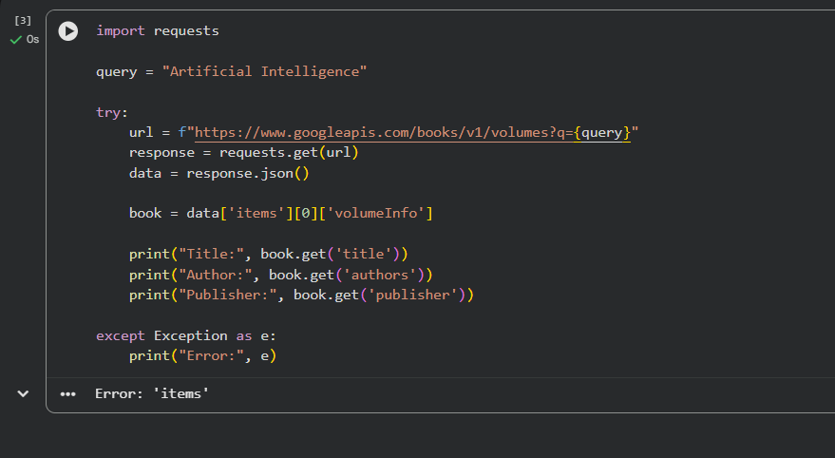

🧩🔥 TASK 4 – Job Listings

💻🐍 Python Code
import requests
keyword = "Python Developer"
try:
url = f"https://remotive.com/api/remote-jobs?search={keyword}"
response = requests.get(url)
data = response.json()
for i, job in enumerate(data['jobs'][:5], 1):
print(i, job['title'], "-", job['company_name'])
except Exception as e:
print("Error:", e)

📸 Screenshots
👉 try:
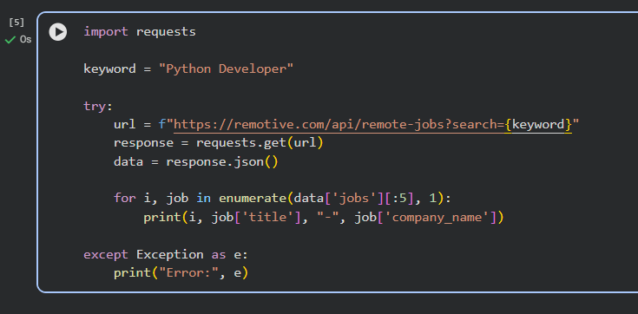

🧩🔥 TASK 5 – Stock API

💻🐍 Python Code
import requests
symbol = "AAPL"
try:
url = f"https://finnhub.io/api/v1/quote?symbol={symbol}&token=demo"
response = requests.get(url)
data = response.json()
print("Current Price:", data['c'])
print("High:", data['h'])
print("Low:", data['l'])
except Exception as e:
print("Error:", e)

📸 Screenshots
👉 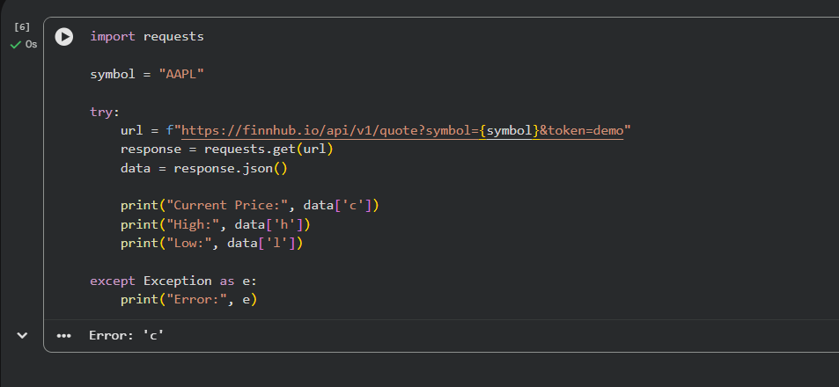

📝✨ Explanation
APIs allow real-time data access. Error handling ensures reliability even when failures occur.

🏁🔥 Conclusion
This lab demonstrates how Python integrates with APIs to fetch real-time data with proper error handling.

🔥

